CASE STUDIES

Name: Mallavarapu Bala Pranitha
Roll.No:2520030051
Section:1[Practical]

Task 1: Create and Manage Files
Objective: Practice creating, listing, viewing, and deleting files.

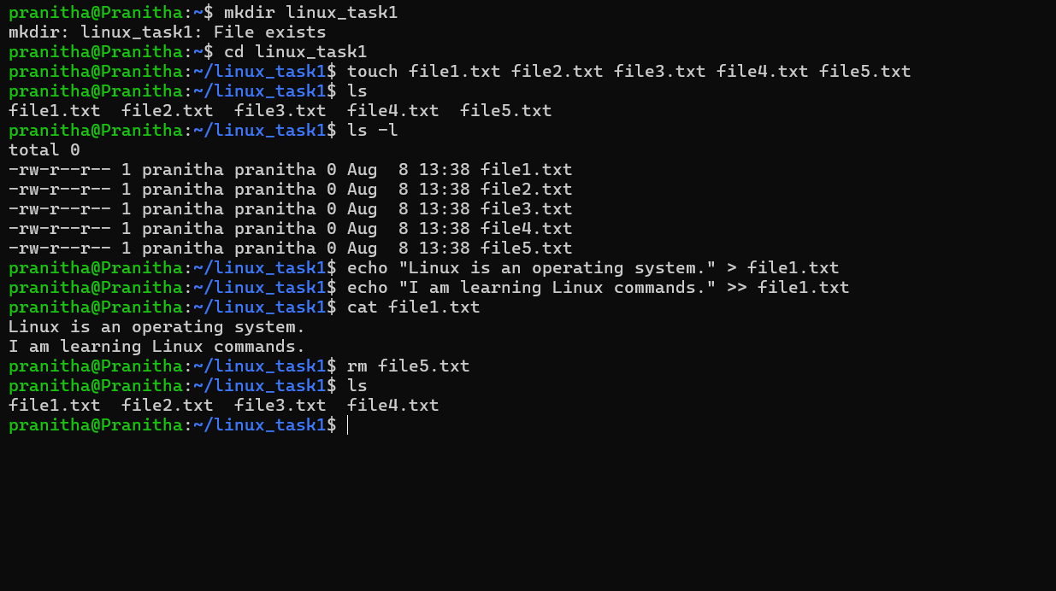

Task 2: Copy and Move Files
Objective: Practice copying and moving files and directories.

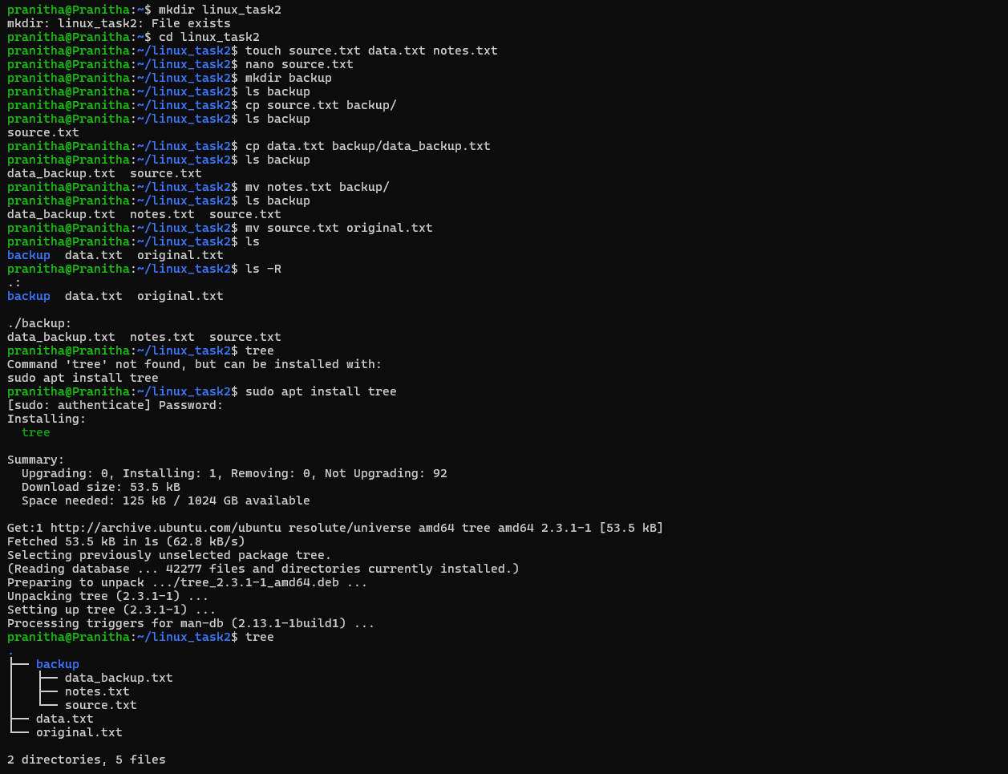

Task 3: Working with head and tail
Objective: Practice viewing specific portions of a file

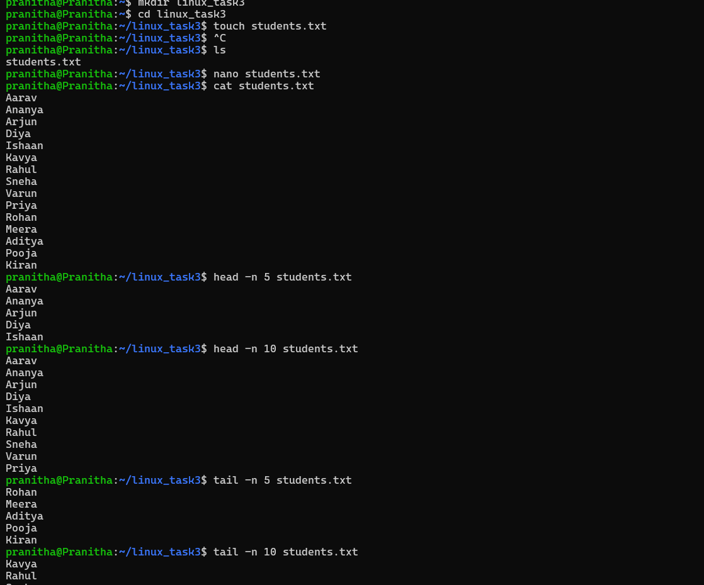

Task 4: Organize Files
Objective: Organize files into different directories using mv

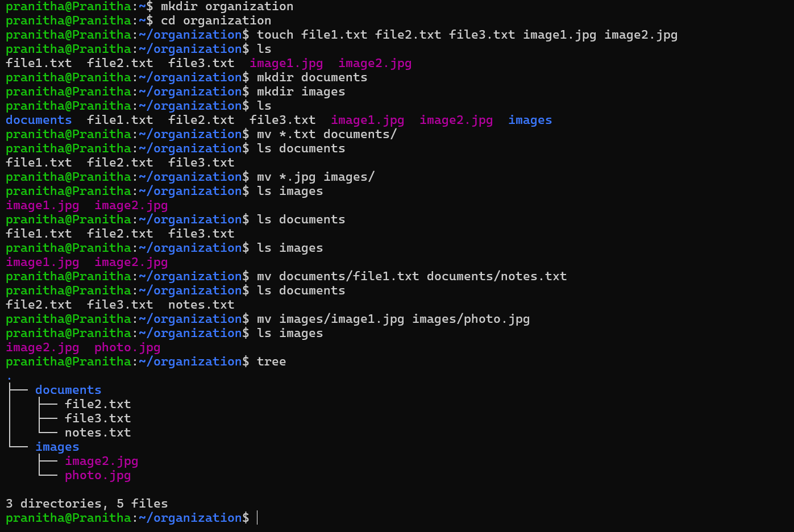

Task 5: Directory Management
Objective: Practice creating nested directories and removing them
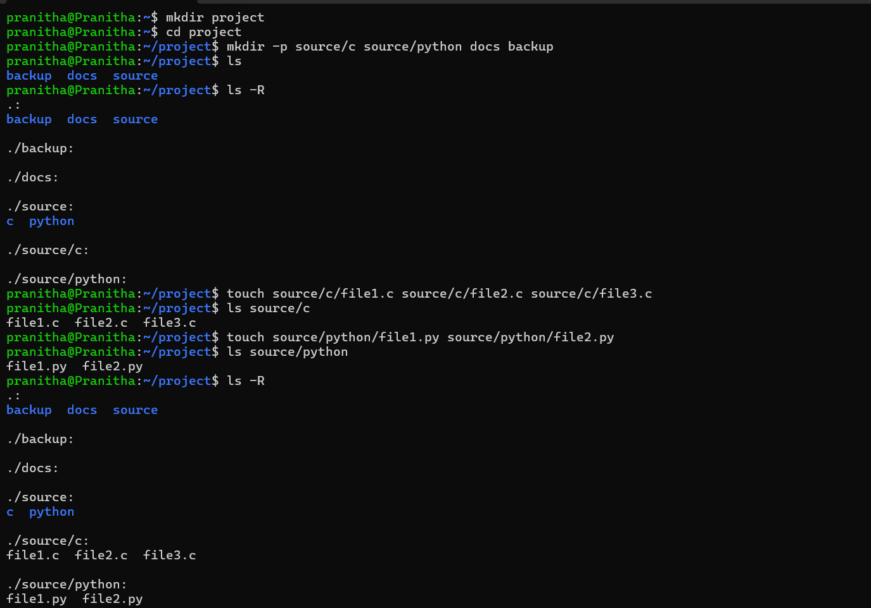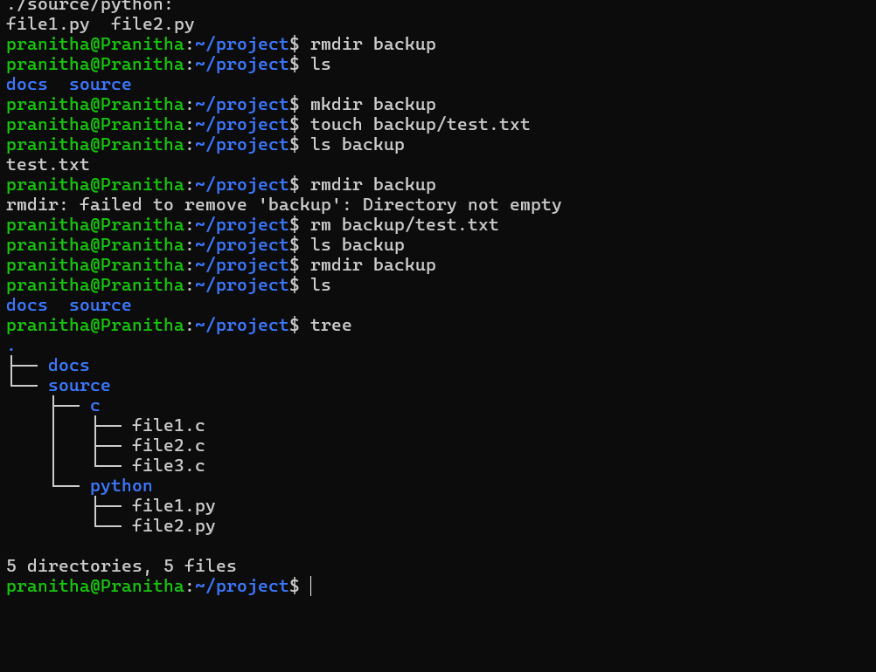

Task 6: File Permissions Using chmod
Objective: Understand Linux file permissions.
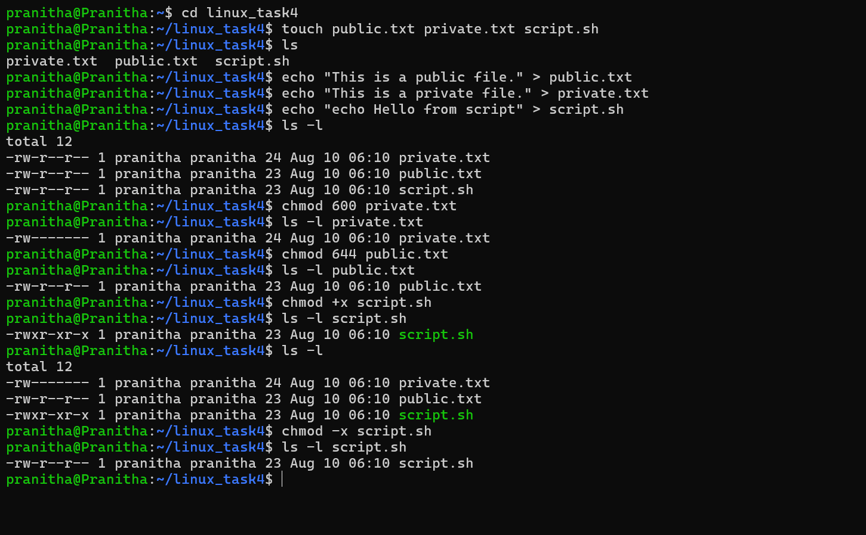

Task 7: File Permission Challenge
Objective: Understand how permissions affect files and directories.

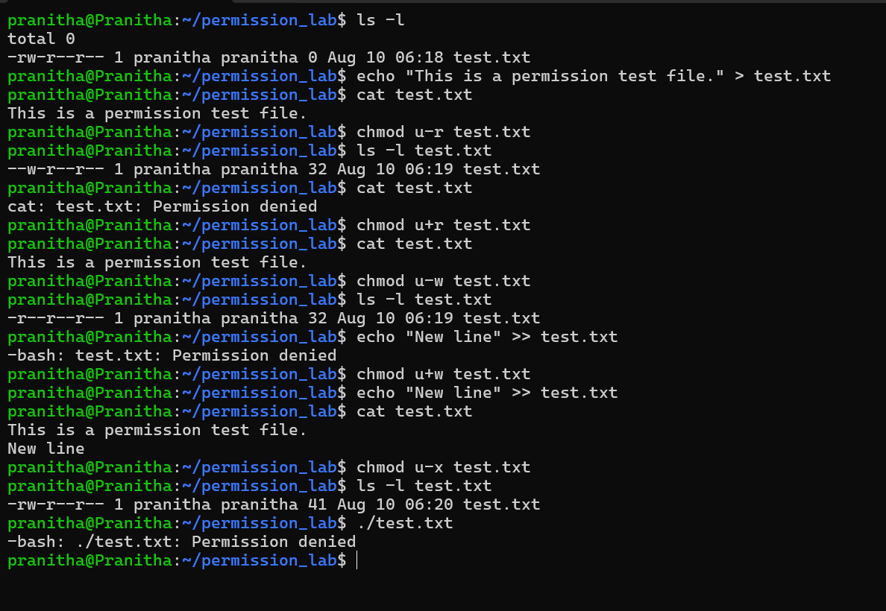

Task 8: Backup and Restore
Objective: Create backups and restore files using cp
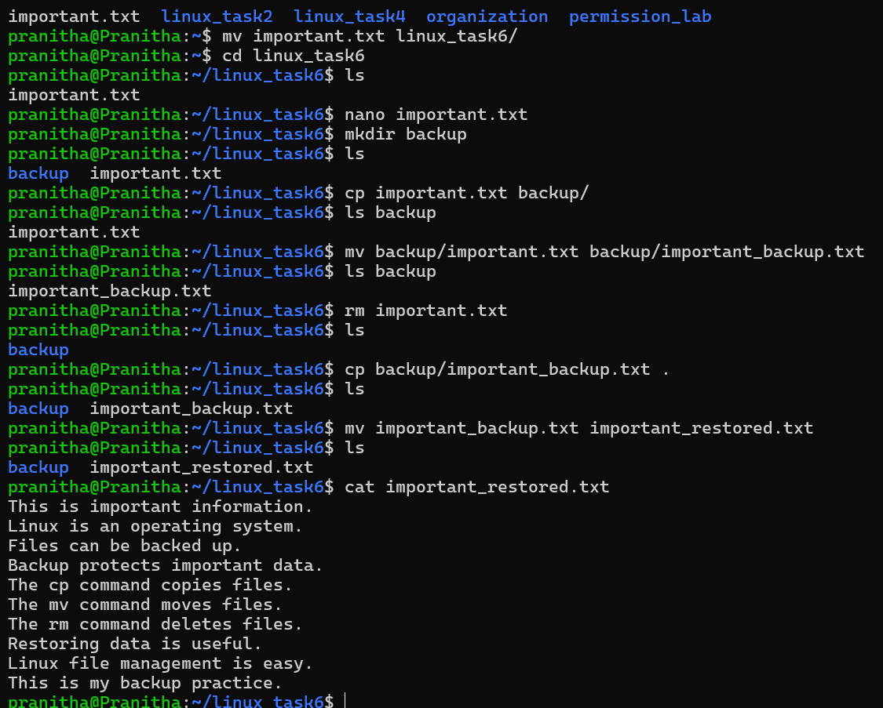

Task 9: Complete Linux File Management Challenge
Objective: Use almost all the commands together.
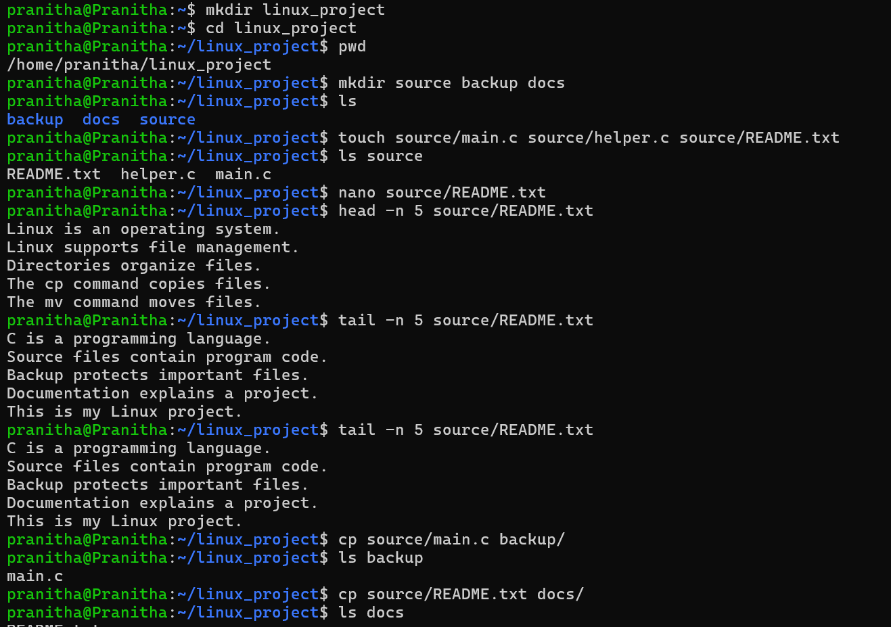
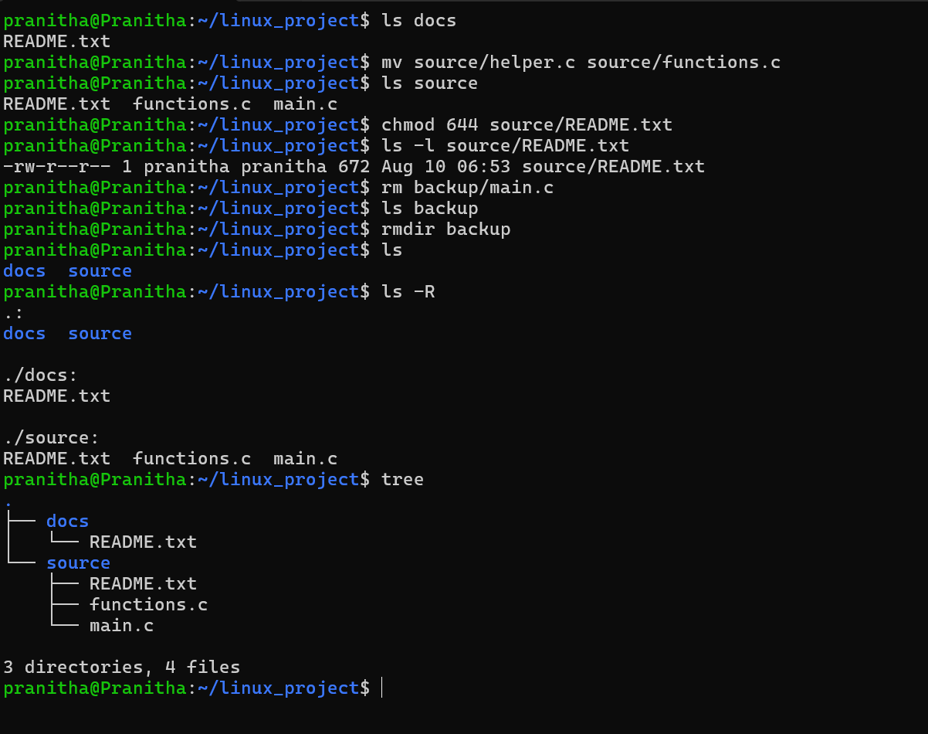
Task 10: Mini Linux Administration Challenge
Objective: Complete a real-world-style file management exercise.
